FORM 2
THE PATENTS ACT,
1970 (39 of 1970)
&
THE PATENTS RULES, 2003

COMPLETE SPECIFICATION
(See Section 10; rule 13)
TITLE OF THE INVENTION

System On-Chip device for smart wearable defibrillator
APPLICANTS
S.No | Name | Address
1. | Dr. P.JEYAKUMAR | Assistant Professor,  Department of ECE,  M.Kumarasamy College of Engineering,  Karur, India-639113
2. | B.YUVAPRABHA | UG Students,  Department of ECE,  M. Kumarasamy College of Engineering  Karur, India-639113
3. | S.VISHWA
4. | P.SUBASH
The following specification particularly describes the invention and the manner in which it is to be performed.The accompanying drawings, which are included in and form a part of the specification, illustrate an incarnation of the present invention and together with the description, serve to explain the principles of the invention. In the drawings

Figure 1: The prototype model of smart wearable defibrillator

System On-Chip device for smart wearable defibrillator

A growing elderly person population along with advances in equipment and approaches for prehospital resuscitation necessitates up-to-date information when developing policies to improve elderly out-of-hospital cardiac arrest outcomes. The defibrillator is one the important devices that plays a major role in today’s wearable medical equipment. It is intended to treat arrhythmias and dysrhythmias. They are the medical complexities, wherein the heart beats at an abnormal rate. Defibrillators stabilize the rhythm of the heart by delivering an electric pulse to the heart, when such a complication occurs. The proposed model of “Smart Wearable Defibrillator” is a best alternative for the existing manually operated defibrillators. It can detect abnormalities at an early stage and delivers a shock pulse automatically according to the level of abnormality. The major problem in existing wearable defibrillators is the ability of patients to use the device correctly. Examples of incorrect use include mainly errors in placing the electrodes and refraining from pressing the response buttons by conscious patients. As mentioned, the former error is avoided in the recent model by an appropriately timed alarm. Training of patients and family members/caregivers is crucial because as many as 10% of patients receiving inappropriate shocks report having forgotten the instructions for use as the reason for not pressing the response buttons. Accordingly, cognitive function should be carefully evaluated in post resuscitation patients with a history of anoxic brain damage. It is estimated that 5% of patients will be unable to use the device correctly.

Background of the Invention
The proposed invention addresses the critical need for timely and accurate intervention during cardiac events by introducing a Smart Wearable Cardioverter Defibrillator (SWCD). With a growing emphasis on wearable medical technology and advancements in deep learning algorithms, the SWCD integrates cutting-edge AI-based Computer-Aided Arrhythmia Classification (CAAC) systems to automatically differentiate between shockable and non-shockable rhythms in ECG signals. By leveraging supervised machine learning methods and deep neural networks, the SWCD ensures rapid and precise diagnosis, enabling prompt delivery of defibrillation therapy when needed. This innovative device represents a significant advancement in cardiac therapy, offering a portable and efficient solution for improving patient outcomes in critical cardiac emergencies.
Objects of the invention
The proposed Smart Wearable Cardioverter Defibrillator (SWCD) serves as an innovative solution in cardiac therapy, aiming to improve outcomes for patients experiencing arrhythmias and dysrhythmias. It integrates advanced deep learning algorithms for real-time classification of ECG signals, distinguishing between shockable and non-shockable rhythms with high accuracy. By automatically detecting critical cardiac events and delivering timely electric pulses to stabilize heart rhythms, the SWCD enhances patient safety and survival rates. Additionally, its wearable design offers convenience and mobility, ensuring continuous monitoring and intervention for individuals at high risk of cardiac emergencies.
Summary of the Invention
The Smart Wearable Cardioverter Defibrillator (SWCD) presents an innovative approach to cardiac therapy, integrating deep learning algorithms for real-time classification of ECG signals, distinguishing between shockable and non-shockable rhythms with high accuracy. By automatically detecting critical cardiac events and delivering timely electric pulses to stabilize heart rhythms, the SWCD enhances patient safety and survival rates. Its wearable design offers convenience and mobility, ensuring continuous monitoring and intervention for individuals at high risk of cardiac emergencies, thereby revolutionizing the landscape of prehospital resuscitation and improving outcomes for patients experiencing arrhythmias and dysrhythmias.

Novelty
- Microwave Therapy:
Microwave therapy represents a significant innovation in medical treatment, harnessing the power of electromagnetic radiation in the microwave frequency range to target and treat various ailments. Unlike traditional therapies, microwave therapy delivers precise and controlled heat energy deep into targeted tissues, offering non-invasive and efficient treatment for conditions such as pain management, cancer therapy, and tissue regeneration. By exploiting the unique properties of microwaves to penetrate biological tissues effectively, microwave therapy holds promise for revolutionizing healthcare by providing safer, faster, and more effective treatment options with fewer side effects and improved patient outcomes.

- Heat sink:
The integration of a heat sink within the Smart Wearable Cardioverter Defibrillator (SWCD) represents a notable innovation in enhancing device performance and longevity. By dissipating excess heat generated during operation, the heat sink ensures optimal thermal management within the device, preventing overheating and maintaining operational efficiency. This novel feature not only enhances the reliability and lifespan of critical components but also contributes to user safety and comfort by preventing discomfort or skin irritation due to excessive heat buildup. Additionally, the incorporation of a heat sink underscores the SWCD's commitment to innovative design and technological advancements, setting it apart as a state-of-the-art solution in wearable medical devices.

- Automatic Shock:
Automatic Shock Delivery represents a significant innovation in the Smart Wearable Cardioverter Defibrillator (SWCD), enabling the device to autonomously administer biphasic electric shocks in response to detected cardiac arrhythmias without the need for manual intervention. This feature relies on real-time analysis of electrocardiogram (ECG) signals using deep learning algorithms, allowing the SWCD to promptly identify shockable rhythms such as ventricular fibrillation or ventricular tachycardia. By automatically delivering shocks when necessary, the SWCD reduces response time during critical cardiac events, potentially improving patient outcomes and increasing the chances of successful defibrillation in emergency situations.

Brief Description of the Drawings
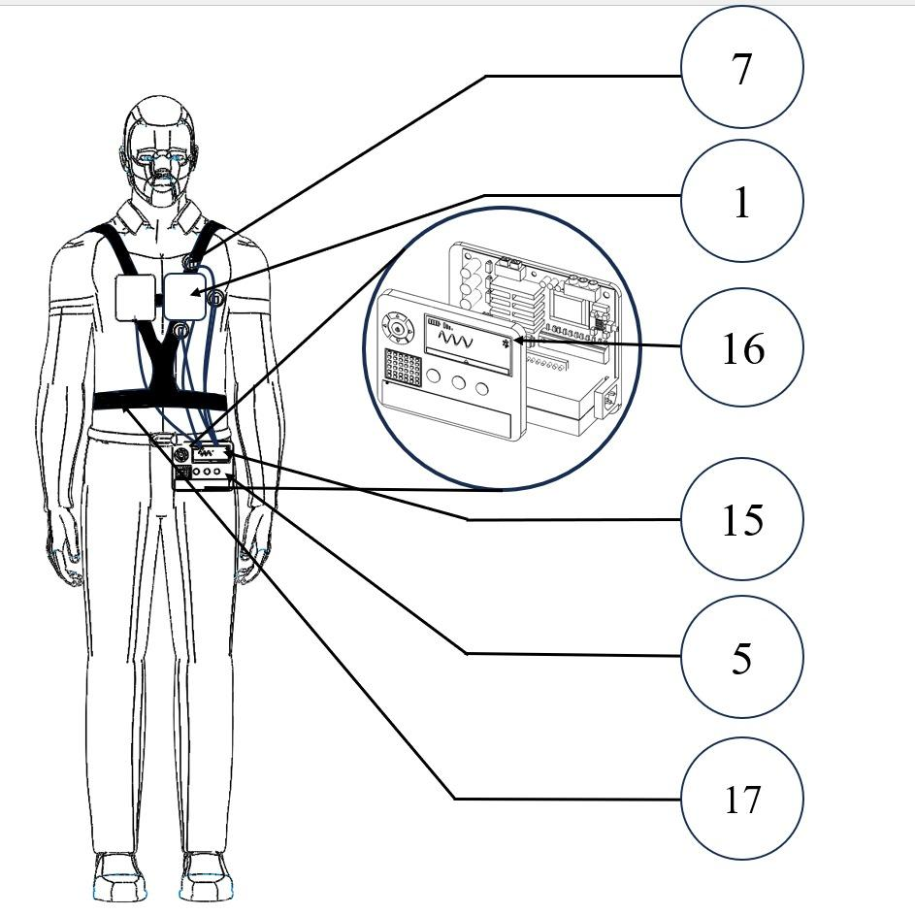
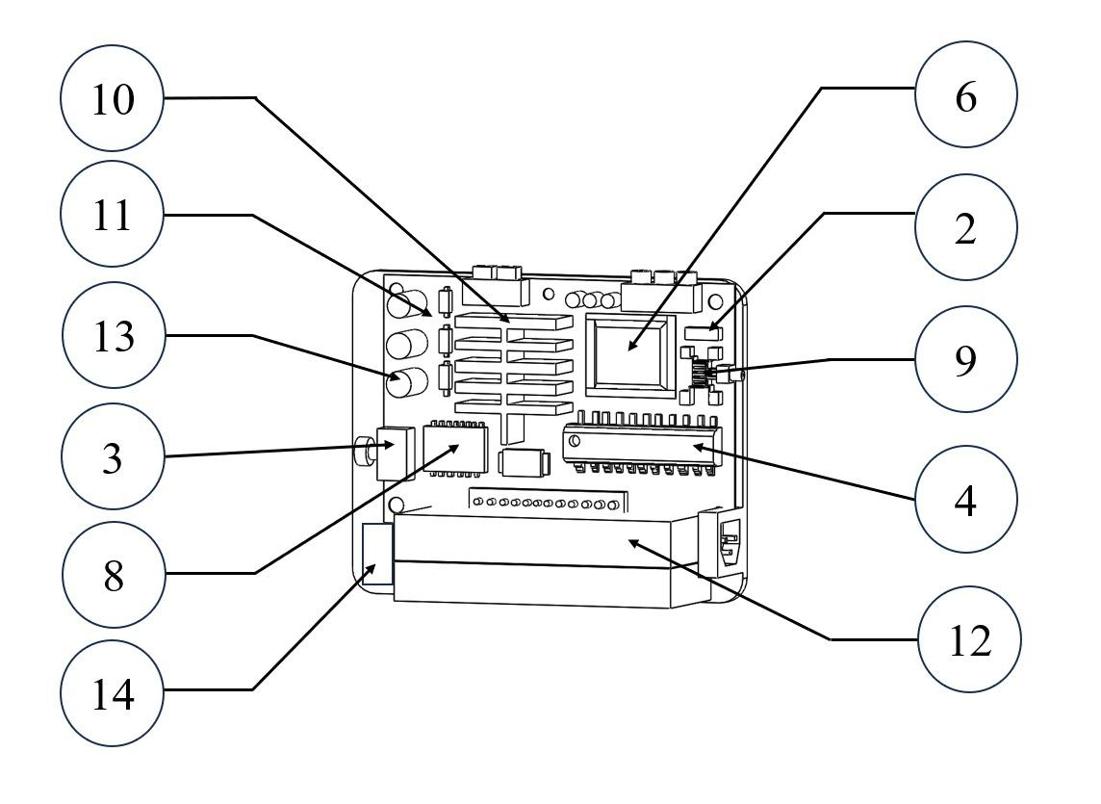
Figure 1: The prototype model of smart wearable defibrillator

1. Electrodes:
The flexible electronics trend emerged as a result of advancements in the electronics industry, which made it possible to create circuits that are flexible. In the field of Bio-sensing, wearable dry electrodes have been developed, eliminating the need for gelling and enabling comfortable measurement of ECG signals. Traditional electrodes made of silver/silver chloride (Ag/AgCl) were used for accurate ECG readings, but to make them flexible, they need to be printed on a suitable substrate to achieve better contact with the skin. Polyethylene terephthalate is commonly used as a flexible substrate due to its biocompatibility, high boiling point, and durability. A conductive polymer layer must be applied between the Ag/AgCl electrodes to eliminate the need for gel and to reduce the contact impedance between the skin and electrode. Carbon nanotubes can be deposited on the Ag/AgCl electrode to improve conductivity between the skin and electrode. The use of wet electrodes with gel poses a disadvantage as the gel can dry out over time, causing inaccurate ECG readings. Once the ECG signal is collected, it is then processed by further blocks.
2. Low Pass Filter Circuit:
A low pass filter permits all frequencies to pass through until the cutoff frequency and suppresses other frequencies. The standard frequency range for an ECG signal is typically between 0.05 and 100Hz. Therefore, to simplify the band pass filter design and eliminate unnecessary noise and frequencies beyond 100Hz, a low pass filter is preferred.

3. Automatic Gain Control Amplifier

An automatic gain amplifier maintains a consistent gain regardless of the input's amplitude. Since the ECG signal has a maximum peak of a few millivolts, it may not be sufficient for the comparator block. To address this issue, a differential pair amplifier, combined with a modified Gilbert cell, introduces a particular gain to a dynamic range of inputs. The Gilbert cell serves as a second stage of amplification. To prevent any potential body effect, the PMOS body is linked to the source while the NMOS body is attached to a low potential.
4. Comparator
As the name suggests, a comparator circuit generally compares two voltage levels and provides a high level ‘1’ or a low level ‘0’ at the output in accordance with the comparison result. The open loop comparator is similar to an operational amplifier working in saturation. Thus when the peak of the ECG signal exceeds the threshold voltage level a low level is obtained at the output and a high level appears when the peak of the ECG signal doesn’t exceed the threshold level. The advantage of the circuit is that it provides high resolution. To avoid body affect the body of the PMOS is connected to the source and the body of the NMOS is connected to low potential.
5. Defibrillating Unit
A defibrillating unit in a smart wearable defibrillator is a component that delivers an electric shock to the heart in case of a cardiac arrest. It is a crucial part of the wearable device and is designed to be compact, lightweight, and easy to use.The defibrillating unit contains a biphasic voltage waveform generator. Since biphasic waveforms were found to have much higher efficiency as per the discussion in the previous sections, the biphasic waveform is generated using Pulse Width Modulation (PWM). The PWM circuit was designed to have a low frequency biphasic waveform. The human ECG signal consists of PQRST waves. The frequency range of P and T waves are 0.5 and 10 Hz respectively and QRS range between 4 and 20Hz. The standard frequency range for ECG signals ranges between 0.05 to 100 Hz. A bandpass filter allows signals only between two specific frequencies. But a low pass allows all signals with frequencies lower than cutoff frequency attenuates higher frequencies. The filter used here is a low pass filter. The input of the filter is the ECG signal. It attenuates the noise and produces the desired response. AC analysis of the filter is obtained with the cutoff frequency of 100Hz. The ECG signal will be in a few millivolts which is not appreciable for the generating shocks. Hence there is a need to amplify the input signal. Automatic gain amplifiers are employed as the input ECG signals vary over a wide dynamic range. The second waveform depicts the input filtered ECG signal with amplitude of 3mV. The first waveform is the output signal with amplitude of 15V. The peak-to-peak 6mV input signal is amplified to 30V peak-to-peak with frequency of 100Hz. It produces constant gain irrespective of the variations in the input signal. The input signal and the reference signal are set to 7.2V and 3V respectively. Here the input signal is an AC sine signal and the reference signal is the DC signal. The input signal is the ECG signal of the person that is being monitored by the device and the reference signal is the standard ECG signal of a normal human being. The comparator now compares the input and the reference signal. The comparator is a circuit which compares the input signal with the reference signal and produces the binary signal as the output. During the positive half cycle, when the input signal is higher than the reference signal the output will be a binary low. During the negative half cycle, when input is lesser than the reference signal the output will be a binary high with an amplitude of 6.6V. When the output of the comparator is low, a shock will be generated which will help the heart to regain its natural pace and overcome the problem of cardiac arrest.
6. Deep learning (DL) Unit:
Deep neural networks, which are extended versions of neural networks, have gained significant attention in computer-aided diagnosis for various diseases in modern days. These networks, consisting of two or more fully connected multilayer perceptrons, are classified into different types such as belief networks, convolutional networks, and fully connected networks. The most significant advantage of deep learning networks is their ability to perform automatic feature extraction. In ECG signal analysis, the commonly used deep learning networks are recurrent neural networks (RNN) and convolutional neural networks (CNN). The feature extraction stage plays a crucial role in data classification and significantly affects the overall system's performance. The use of deep learning networks enhances the robustness of a computer-aided diagnosis system compared to a machine learning-based system, where manual feature extraction is necessary. Generally, deep learning algorithms are more effective than classical machine learning algorithms in detecting shockable ECG signals. However, a major limitation of deep learning is the requirement of a large number of training samples to train the networks for better performance.
i. Preprocessing:
To achieve high classification accuracy, robust preprocessing algorithms are crucial. This initial step involves reducing noise in the ECG signal by smoothing it, suppressing drift and baseline wander, and preparing it for subsequent processes. The following methods are commonly employed to reduce signal noise: (i) Second-order low-pass and high-pass Butterworth filtering, (ii) Daubechies wavelet 6 (db6), and (iii) Orthogonal wavelet filter. Previous studies have also segmented ECG signals into beats or segments of different durations (e.g., 2 and 5 s) before extracting features. The Pan-Tompkins algorithm, which detects ECG R-peaks for segmentation, is a popular algorithm used for this purpose.
ii. Feature extraction:
The feature extraction stage, deemed the most critical stage in machine learning, follows the preprocessing stage. Prior studies have mainly concentrated on devising optimal methods for feature extraction. Common features extracted for diagnosing shockable ECG rhythms can be categorized into four groups: temporal/morphological features, spectral features, time-frequency/wavelet features, and complexity features (nonlinear features). Due to the time-varying and unpredictable nature of ECG signals, complexity features have gained more attention as an effective feature extraction method for shockable diagnosis in computer-aided diagnosis systems.
iii. Feature selection:
The feature selection stage is critical in removing redundant features, reducing computational costs, and enhancing the system's overall performance. This stage employs three primary categories of feature selection methods: (a) wrapper methods, (b) filter methods, and (c) embedded methods.
a) The wrapper approach is regarded as the most accurate method for feature selection, albeit at the expense of increased computational complexity. This technique employs cross-validation by training the model multiple times using different sets of features and comparing the outcomes. Recursive feature elimination, forward feature selection, and genetic algorithms are the commonly used methods in this approach.
b) The filter approach selects the optimal set of features based on statistical measures before the training process. The evaluation of features is done against a proxy measure rather than cross-validation accuracy. The prevalent techniques in this approach are correlation, chi-squared, analysis of variance (ANOVA).
c) The embedded approach encompasses methods that do not fit into the wrapper or filter categories. An example of such a method is L1 regularization.
iv. Features reduction:
At this stage, a smaller set of new variables is created, each composed of a blend of input variables that contain the same information as the entire set of input variables. Numerous feature reduction techniques are available to transform the selected features into a low-dimensional space. For instance, principal component analysis (PCA), linear discriminant analysis (LDA), and locality-sensitive discriminant analysis (LSDA) are common feature reduction techniques.
v. Classification:
The final step in ECG signal analysis is classification, where the input ECG signal is categorized after selecting the crucial features. Classification methods can be broadly categorized into two types: supervised learning and unsupervised learning. In supervised learning, the outcomes are predefined, whereas in unsupervised learning, class membership is determined based on clustering. As previous records with predetermined results (e.g., shockable rhythm versus non-shockable rhythm) are available when designing a CAAC system, supervised ML methods are widely employed. These methods can be further divided into the classification or regression category. Since the output of a CAAC system is a discrete set of output labels, conventional classification algorithms such as Support Vector Machines (SVMs), Naïve Bayes Classifier, k-Nearest Neighbors (k-NNs), Decision Trees (DT), and ensemble classifiers are commonly used in identifying shockable arrhythmias.
7. Electrode adhesive patches:
In the System On-Chip (SoC) device for a smart wearable defibrillator, electrode adhesive patches play a crucial role in ensuring accurate acquisition of electrocardiogram (ECG) signals from the patient's chest. These patches securely attach Ag/AgCl electrodes to the skin, establishing consistent and stable contact between the electrodes and the body surface. By providing a standardized method for electrode placement and ensuring firm adhesion to the skin, the patches minimize motion artifacts and interference, thereby enhancing signal quality. Additionally, they are designed for wearer comfort, featuring hypoallergenic materials and non-irritating adhesives to facilitate extended wearability. Whether disposable for single-use applications or reusable with proper maintenance, these adhesive patches contribute to the durability and reliability of the SoC device, enabling continuous monitoring and effective management of cardiac arrhythmias.
8. Signal conditioning circuitry:
In the System On-Chip (SoC) device for the smart wearable defibrillator, the signal conditioning circuitry plays a crucial role in preprocessing the electrocardiogram (ECG) signals. This circuitry consists of amplifiers, filters, and analog-to-digital converters (ADCs) designed to enhance the quality and accuracy of the ECG data before further processing. Amplifiers ensure optimal signal strength, filters eliminate unwanted noise and artifacts, and ADCs digitize the analog signals for subsequent digital processing by the SoC unit. Together, these components enable reliable and accurate analysis of the ECG signals, enhancing the performance and effectiveness of the wearable defibrillator in detecting and responding to cardiac abnormalities.
9. Microwave therapy module:
Microwave therapy harnesses high-frequency electromagnetic waves generated by a microwave generator to selectively heat and destroy specific tissues within the body. This innovative therapeutic approach offers a minimally invasive alternative for treating conditions like cancer and chronic pain. The microwave generator produces electromagnetic waves within the microwave frequency range, typically between 915 MHz to 2.45 GHz. Microwave therapy integrated into a System On-Chip (SoC) device for a smart wearable defibrillator can enhance treatment of cardiac arrhythmias by providing targeted tissue ablation, reducing the need for high-energy shocks, and offering a non-invasive, more comfortable alternative to traditional defibrillation. This integration allows for real-time monitoring and adjustment, improving therapy effectiveness and patient compliance. Additionally, the device can continuously manage heart rhythms, collecting detailed data to refine treatments and personalize therapy, all while ensuring efficient power management and user-friendly operation. This advancement in wearable defibrillator technology can significantly improve patient outcomes and quality of life.
10.Heat Sink:
In a System On-Chip (SoC) device for a smart wearable defibrillator, a heat sink plays a crucial role in managing the thermal performance of the integrated circuits (ICs) within the SoC. As the SoC operates, it generates heat due to the flow of current through its components and the switching of transistors. This heat can lead to a rise in temperature, potentially affecting the performance and reliability of the device. The heat sink acts as a passive cooling solution by dissipating the heat generated by the ICs into the surrounding environment. It typically consists of a thermally conductive material, such as aluminum or copper, with a large surface area to efficiently transfer heat away from the ICs. The heat sink is often attached directly to the ICs or the SoC package using thermal interface materials, such as thermal paste or thermal pads, to ensure optimal heat transfer. The design of the heat sink is carefully optimized to provide effective cooling while maintaining the compact and lightweight nature of the device. Additionally, considerations such as power consumption, ambient temperature, and thermal management strategies are essential in ensuring the reliability and performance of the SoC device in demanding environments.\

11. Microcontroller:
Within the System On-Chip (SoC) device for the smart wearable defibrillator, the microcontroller acts as the central processing unit, orchestrating critical functions for real-time monitoring and intervention. It facilitates signal processing tasks such as filtering, amplification, and digitization of raw ECG signals to ensure accurate data acquisition. Additionally, the microcontroller enables the implementation of deep learning frameworks for automatic feature extraction and classification of ECG rhythms, enabling the device to distinguish between shockable and non-shockable conditions with high accuracy. Moreover, it coordinates the operation of various components within the SoC device, manages power consumption to optimize battery life, and interfaces with user input devices and display interfaces to facilitate user interaction. Ultimately, the microcontroller plays a pivotal role in ensuring the effectiveness and reliability of the smart wearable defibrillator, contributing to improved patient outcomes in cardiac emergencies.

12. Battery pack:
In the System on Chip (SoC) device for a smart wearable defibrillator, the integration of a battery pack is not typical within the SoC itself. However, the SoC plays a crucial role in managing power consumption and regulating power from an external battery pack or power source. This includes tasks such as power regulation to ensure stable operation of all components, implementation of low-power modes to minimize energy consumption during idle periods, and monitoring battery voltage levels to prevent depletion. Additionally, the SoC may include charging control circuitry for rechargeable batteries, optimizing power efficiency through dynamic adjustments, and providing emergency power reserve functionality to ensure critical operations, like defibrillation, can continue even with low battery levels. These features collectively contribute to the efficient and reliable operation of the wearable defibrillator while maximizing battery life and ensuring uninterrupted functionality during critical situations.
13. Capacitors:
In the System On-Chip (SoC) device for the smart wearable defibrillator, capacitors play a critical role in storing electrical energy required for delivering defibrillation shocks to the heart. These capacitors act as energy storage units, accumulating charge from the power source (such as a rechargeable battery) during the charging phase of the defibrillation cycle. When a shock is required, the capacitors discharge rapidly, releasing the stored energy as a controlled electric pulse that is delivered to the patient's heart through the defibrillation electrodes. The capacitance value and voltage rating of these capacitors are carefully selected to meet the energy requirements and safety standards of the defibrillation process, ensuring effective and reliable delivery of therapeutic shocks while minimizing risks to the patient. Additionally, charge control circuitry is employed to regulate the charging and discharging processes of these capacitors, ensuring precise control over the energy delivery and optimizing the performance of the defibrillator system.
14. Charge control circuitry:
The charge control circuitry within the System On-Chip (SoC) device for a smart wearable defibrillator is instrumental in managing the crucial process of charging and discharging capacitors used for delivering electric shocks to the patient's heart. This circuitry comprises a charging circuit responsible for efficiently regulating the input voltage, boosting it to the required level, and controlling the charging current to prevent overcharging. Simultaneously, a discharging circuit oversees the controlled release of stored energy from the capacitors, triggered at the appropriate time by a switching mechanism and coordinated by discharge control logic. Integral safety features, including voltage monitoring, fault detection, and isolation mechanisms, ensure optimal performance and mitigate risks of malfunctions or hazards. This circuitry interfaces with the SoC's microcontroller for command reception and integrates user interfaces to provide real-time feedback on charging status and safety alerts. Collectively, the charge control circuitry ensures the smart wearable defibrillator's reliable operation, enabling timely and effective delivery of electric shocks to restore normal cardiac rhythm during emergencies.
15. Display:
In the System On-Chip (SoC) device for the smart wearable defibrillator, the display serves as a crucial component for providing feedback to the user and presenting essential information about the device status and patient's condition. It offers real-time visual feedback, indicating the device's operational status, battery level, and connectivity status, ensuring users are informed about its readiness and functionality. Additionally, the display presents the captured ECG waveform in real-time, enabling healthcare providers to monitor the patient's heart rhythm continuously and identify any abnormalities promptly. In critical situations, such as detecting shockable rhythms or low battery levels, the display alerts the user with visual alarms and notifications, ensuring timely response. It also facilitates menu navigation and settings adjustment, allowing users to customize device parameters and receive instructional messages and guidance prompts for effective operation. Moreover, the display may provide data analytics tools for reviewing historical ECG data and event logs, supporting healthcare providers in assessing patient trends and treatment effectiveness. Overall, the display plays a vital role in user interaction, patient monitoring, and emergency response, contributing to the device's effectiveness in improving cardiac care outcomes.
16. Bluetooth module:
The Bluetooth module integrated into the System On-Chip (SoC) device for the smart wearable defibrillator serves as a pivotal component for facilitating wireless communication with external devices. Utilizing Bluetooth Low Energy (BLE) technology, the module enables seamless transmission of data, including real-time ECG signals and device status updates, to smartphones, tablets, or medical monitoring systems. This wireless connectivity allows healthcare professionals or caregivers to remotely monitor the patient's cardiac activity, receive alerts in case of critical events, and adjust device settings as needed, enhancing patient care and intervention efficiency. Additionally, the Bluetooth module supports bidirectional communication, enabling the smart wearable defibrillator to receive commands or updates from external devices, ensuring adaptability and interoperability within the healthcare ecosystem.
17. Adjustable belts:
The inclusion of adjustable belts within the System On-Chip (SoC) device for the smart wearable defibrillator enhances its usability and comfort for patients. These adjustable belts provide a secure and customized fit, ensuring that the device remains in place during daily activities without causing discomfort or restriction. By offering flexibility in sizing and fit, the adjustable belts accommodate various body types and preferences, optimizing the user experience and promoting long-term compliance with wearing the defibrillator. Additionally, the belts contribute to the overall design integrity of the SoC device, complementing its compact and lightweight form factor while maintaining functionality and reliability in delivering life-saving interventions for cardiac emergencies.

Claims
I/We Claim,
Our claim is an innovative automatic shock delivery system, wherein deep learning algorithms analyze real-time electrocardiogram (ECG) signals to autonomously detect and classify shockable cardiac rhythms, enabling the device to administer biphasic electric shocks without manual intervention.
Signature of Applicants:
Dr.P.JEYAKUMAR | B.YUVAPRABHA | S.VISHWA | P.SUBASH

Abstract
The Smart Wearable Cardioverter Defibrillator (SWCD) presents a novel solution for cardiac therapy by integrating advanced technology into a wearable device. Utilizing Ag/AgCl electrodes and signal conditioning circuitry, the SWCD captures and preprocesses electrocardiogram (ECG) signals from the patient's chest. A microcontroller, coupled with deep learning frameworks, enables real-time analysis and classification of ECG rhythms, distinguishing between shockable and non-shockable conditions. The prototype incorporates rechargeable battery packs and charge control circuitry for delivering biphasic electric shocks when necessary. User interaction is facilitated through a display interface and input controls, while wireless connectivity options such as Bluetooth and Wi-Fi enable data transmission to external devices. Encased in a protective enclosure and secured with adjustable straps, the SWCD offers mobility and comfort for continuous monitoring and intervention in cardiac emergencies. This abstract highlights the SWCD's potential to revolutionize prehospital resuscitation, improving outcomes for individuals experiencing arrhythmias and dysrhythmias.

